Helping People Who Are Vision Impaired
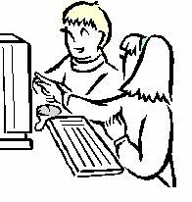
Module 2 Disabilities in Society

There are some issues that come up everyday for people who are vision impaired or blind. Many of these problems could be improved if resources were provided to help people with vision impairments.

In a classroom there can be many hurdles for someone who is vision impaired. Can you think of any?

Eg: Using writing that is light in colour eg: yellow, orange and small to see

1
2
3
4
5

What are some things that could be implemented or done to remove these hurdles?

Eg: Using writing that is bold and of a large font.

1
2
3
4
5
© 2007 Association for the Blind of Western Australia
Exceptions: Images
© Microsoft Office Clip Art 2007

